animago 2019: Submissions are now open!
The 23rd edition of animago is coming up and submission for 3D animation projects, visual effects, design and the like is open now! This year, the coveted animago trophy will be awarded in 10 categories, with “Best In-Game Graphics” being a brand new category for 2019.
Munich, May 22nd 2019 – Submissions are possible until June, 30th 2019 and are completely free of charge. Submitted projects are reviewed and evaluated by an independent jury comprising renowned experts from the industry. The final winner of the “Best Still” category will be determined by an online public vote. The grand award ceremony will take place on Saturday, November 2nd in the Alte Kongresshalle in Munich.

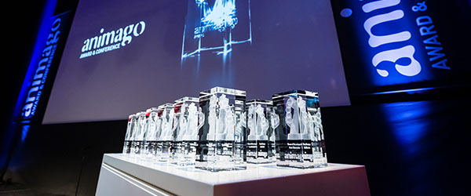

The 10 categories:
- NEW: Best In-Game Graphics
- Best Visual Effects
- Best Game Cinematic
- Best Short Film
- Best Advertising Production
- Best Character
- Best Young Production (3,000 Euro prize money sponsored by Digital Production)
- Jury’s Prize
- Best Motion Design
- Best Still (determined by public voting)
In the new category "Best In-Game-Graphics" graphics are evaluated as they appear in the actual game – not in pre-rendered sequences. Special attention is paid to character design, animation, game flow and the realism of movement. In the "Best Still" category, the winner out of three nominees will be determined by an online public vote.
>> To submit your project follow this link

Since the first issue of the animago 23 years ago, about 25,000 projects from around 90 countries have been submitted, viewed and evaluated. This year the animago will be bigger than ever: The animago CONFERENCE will take place from November 2nd to 5th 2019 and will be attended by top-class speakers and leading experts of the industry. At the same time, renowned brands will present themselves at the animago EXHIBITION.
Press Material
- Logos and images for journalistic use can be found in the animago press area: www.animago.com/en/press/
- More information about animago are available at the homepage: www.animago.com
Due to the increasing importance for the industry and the ongoing success animago partners up with the Munich-based communications and content agency 138 Alternatives. From now on, the 138 team supports animago in terms of media work and will take care of any press request relating to the animago event in 2019.
The animago 2019 is hosted by Digital Production. The bimonthly magazine reports on tools and workflows for all aspects of digital media production. The print version is published in German, the online version is also available in English. Digital Production is published by DETAIL Business Information GmbH. Our website: www.digitalproduction.com

Press Contact Project Management
Philipp Reiff Arian Schlichenmayer
Alternative 138 GmbH DETAIL Business Information GmbH
T: +49 176 25 80 80 34 T: +49 89 381 620 592
E: philipp@alternative138.com E: as@animago.com

