animago 2019: Extended Deadline For Submissions
The deadline for submissions for the animago 2019 has been extended by one month to the 31stof July 2019.
Until then, projects from the world of visual effects, 3D animation, CGI and more can be submitted on the website www.animago.com. This year, the best international works will be assesed by a top-class jury in a total of ten categories.
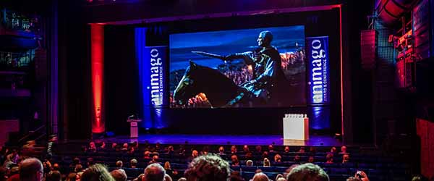
As in the previous years, no participation fee will be charged for submitting projects to the animago event and submissions can be made conveniently via the website. The number of entries that can be submitted to the competition is unlimited. Both pictures and films can be submitted. A requirement for participation is a significant computer-generated amount, whereby a combination with real elements is permitted.
Direct link to the animago submission form. More information regarding the animago 2019 is available at the FAQ page or in the submission guidelines.
The 2019 edition of animago will take place from the 2nduntil the 5thof November 2019 in the Alte Kongresshalle in Munich. The award ceremony will take place in the evening of the 2ndNovember 2019.
Press Material
- Logos and images for journalistic use can be found in the animago press area: www.animago.com/en/press/
- More information about animago are available at the homepage: www.animago.com
The animago 2019 is hosted by Digital Production. The bimonthly magazine reports on tools and workflows for all aspects of digital media production. The print version is published in German, the online version is also available in English. Digital Production is published by DETAIL Business Information GmbH. Our website: www.digitalproduction.com

Press Contact Project Management
Philipp Reiff Arian Schlichenmayer
Alternative 138 GmbH DETAIL Business Information GmbH
T: +49 176 25 80 80 34 T: +49 89 381 620 592
E: philipp@alternative138.com E: as@animago.com

