animago AWARD 2019 – and the winner is …
The winners of animago 2019, the international competition for 3D animation, still, visual effects and game, have been announced.
Munich, November 3rd 2019: 500 guests watched the award ceremony in the Alte Kongresshalle in Munich, where the event celebrates its 23rd anniversary. 1,137 submissions from 62 countries across the globe were submitted this year.

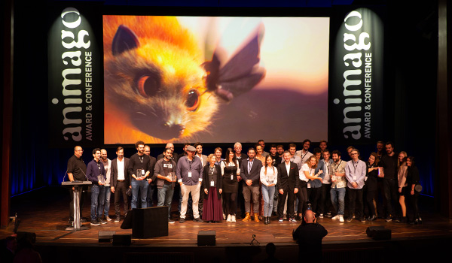

The award is part of the animago CONFERENCE (November 2nd-5th 2019), attended by top-class speakers and leading experts of the industry talking about current trends and developments, grant insights and reveal their latest tools and tricks.

The winners of the 10 categories:
- Best Short Film
“The Pig on the Hill” – Jamy Wheless, John Helms
Lightstream Animation Studios, USA
Crater Studio, Serbia
Teaser: https://www.facebook.com/animagoAWARD/videos/2453528221602920/

- Best In-Game-Graphics
“Shadow of the Tomb Raider”
Eidos Montréal, Crystal Dynamics, Square Enix, Canada/USA/GERMANY
Teaser:https://www.facebook.com/animagoAWARD/videos/2485306741750454/

- Best Advertising Production
“Christmas Doesn't Need Much. Only Love.”
Glassworks Amsterdam, Netherlands
PENNY Markt
https://www.youtube.com/watch?v=QZ5rjTWvNck

- Best Young Production
„The Ostrich Politic“ – Mohammad Houhou
GOBELINS, l'école de l'image, France
Teaser: https://youtu.be/ALl1nxi7wx0

- Best Visual Effects
“Fantastic Beasts: The Crimes of Grindelwald”
VFX by Rodeo FX, Canada, for Warner Bros
Teaser: https://www.youtube.com/watch?v=8bYBOVWLNIs

- Best Character
“Sous la glace” – Milan Baulard, Ismaïl Berrahma, Flore Dupont, Laurie Estampes, Quentin Nory, Hugo Potin, École des Nouvelles Images, France
Teaser: https://www.facebook.com/animagoAWARD/videos/2488170717931725/

- Best Still
“Subarctic Great Horned Owl: look into the depths”
Yuriy Dulich, Ukraine
Image Download: https://drive.google.com/open?id=1I5KFIQ7du2TASi90QITyeW1gdUUnOthS

- Best Game Cinematic
“METRO Exodus: Artyom's Nightmare” – Tomek Suwalski, Polen
Platige Image for Deep Silver
Teaser: https://www.youtube.com/watch?v=ynB-SjMJsP8

- Best Motion Design
„Hurlevent“ – Frédéric Doazan, Frankreich
Teaser: https://www.facebook.com/watch/?v=434190983902634

- Jury’s Prize
“The Beauty” – Pascal Schelbli, Germany
Filmakademie Baden-Württemberg
Teaser: https://www.facebook.com/animagoAWARD/videos/538262626929846/

Press Material
- Images of the animago AWARD 2019 and the 10 winners.
- Logos and images for journalistic use can be found in the animago press area: www.animago.com/en/press/
- More information about animago are available at the homepage: www.animago.com

Press contact Project Management
Philipp Reiff Arian Schlichenmayer
Alternative 138 GmbH DETAIL Business Information GmbH
T: +49 176 25 80 80 34 T: +49 89 381 620 592
E: philipp@alternative138.com E: as@animago.com
www.138alternatives.com www.animago.com

